The University of Azad Jammu & Kashmir, Muzaffarabad


Department: Software Engineering
Course Title: Programming Fundamental
Course Code: CS-1101
Project Title Library Management System
Student Name: Muhammad Hammad Malik
Roll No: 2025-SE-20
Instructor Name: Engr. Muhammad Awais
Submission Date: 02-02-2026

“Library Management System”

1. Introduction:
A Library Management System (LMS) is a simple software application that helps manage the day-to-day operations of a library. It allows librarians to add new books, track existing books, update book details, search for books, and delete records efficiently.
This system is developed in C++ and is console-based, making it ideal for beginners learning programming fundamentals. The project demonstrates key concepts such as arrays, functions, loops, conditional statements, pointers, and call by reference.
Using an LMS helps organize library data, reduce manual errors, and save time in managing books, even in a small library setting.

2. Core Features:
The Library Management System includes the following main features:
- Add Books – Input new book details such as ID, title, author, and quantity.
- Display Books – Show a list of all books currently in the library.
- Search Book – Find a book by its ID to view its details.
- Update Book – Modify book information using the book ID.
- Delete Book – Remove a book record from the library.
These features are designed to cover basic operations of a real library in a simple way for learning purposes.

3. Core Programming Concepts Used:
The project demonstrates the following programming fundamentals:
Concept | How it is used in LMS
Program Structure | Organized using functions for each operation.
Comments | Explain code for better understanding.
Data Types | int, char arrays for storing book details.
Variables & Constants | Variables store book information; constants limit maximum books.
Input / Output | cin for input, cout for output.
Operators | Used arithmetic, assignment, comparison, and logical operators.
If–else & Ternary Operator | Decision-making for checking book existence.
Loops | for, while, do-while loops for processing multiple books.
Functions | Separate functions for add, display, search, update, and delete operations.
Arrays | Store multiple books using an array of structures.
Strings (char array) | Store book title and author.
Pointers | Pass book array to functions.
Call by Reference | Update and delete books directly in the array.

4. Flowchart of the Program:
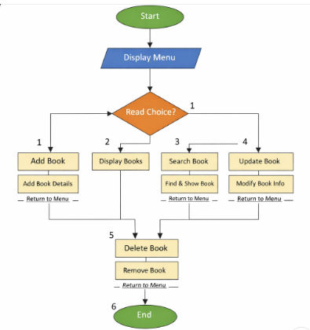

5. Sample Output:
Add the book:
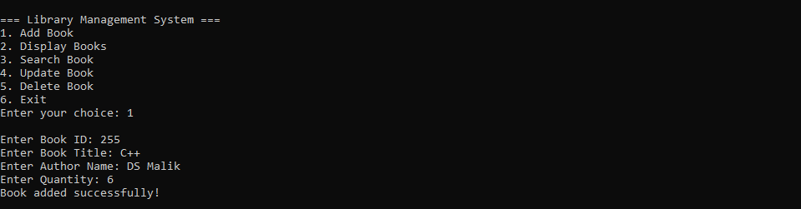

Display the book:

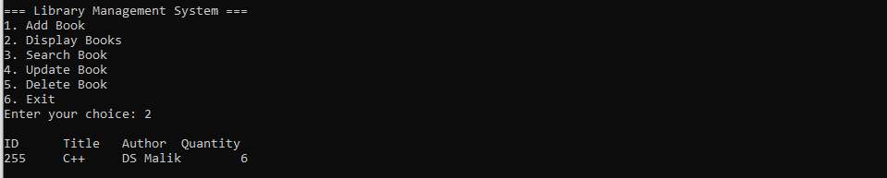

Search book:

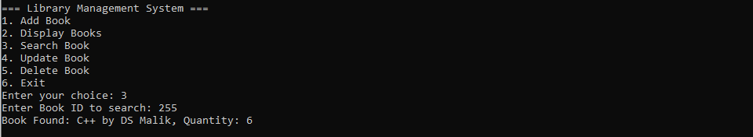
Update book:

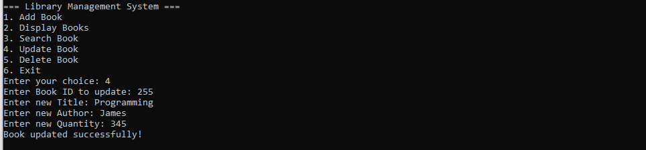

Delete book:

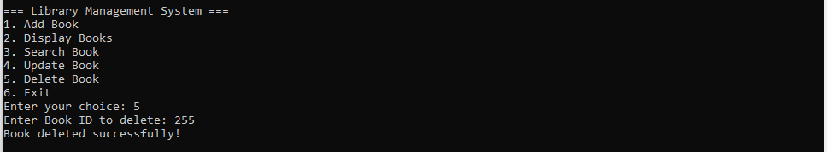

Exiting the program:

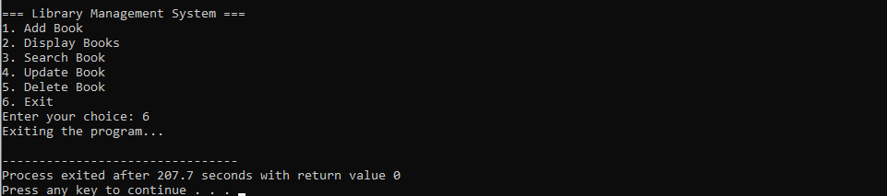

THE END

